Name: Maira Malik
Reg.no: 2023-BSE-040
Subject: Cloud Computing

Assignment # 1
Task 1:
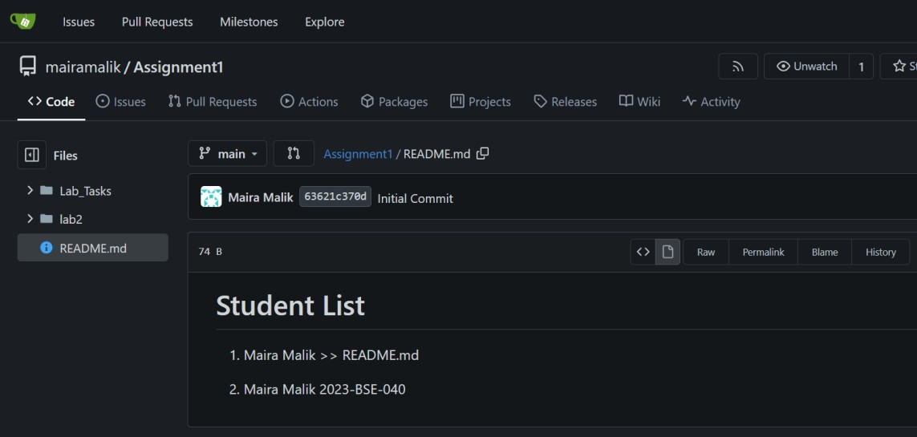
Task 2:
Assignment 1 Repo link: https://github.com/Maira222/Assignment1 Task 3:
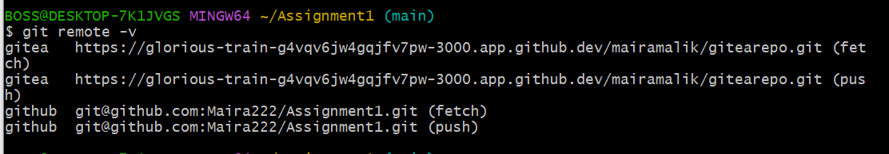
Task 4:
CV/Portfolio pages link:
https://maira222.github.io/mairamalik.github.io/

